

A computing toolkit for building efficient autonomous applications leveraging humanistic intelligence (TEACHING)

**D5.1: Initial use case specifications[1]†**

|  |  |
| --- | --- |
| Contractual Date of Delivery | 30/06/2020 |
| Actual Date of Delivery | 30/12/2020 |
| Deliverable Security Class | Confidential |
| Editor | Omar Veledar (AVL) |
| Contributors | Davide Bacciu, Daniele Mazzei, Gabriele Mencagli (UNIPI)  Konstantinos Tserpes, Dimitrios Michail, Iraklis Varlamis, Charalampos Davalas, Christos Sardianos (HUA)  Patrizio Dazzi (CNR)  Georg Macher, Juergen Dobaj, Maid Dzambic (TUG)  Herbert Danzinger, Philipp Clement, Omar Veledar (AVL)  Lorenzo Giraudi, Roberta Peroglio (I&M)  Calogero Calandra, Marilina De Gennaro, Sara Rosaria Potenza (M)  Sylvain Girbal, Jimmy Le Rhun (TRT)  Siranush Akarmazyan (ITML) |
| Quality Assurance | Reviewer: Georg Macher (TUG) |

**The TEACHING Consortium**

|  |  |  |
| --- | --- | --- |
| University of Pisa (UNIPI) | Coordinator | Italy |
| Harokopio University of Athens (HUA) | Principal Contractor | Greece |
| Consiglio Nazionale delle Ricerche  (CNR) | Principal Contractor | Italy |
| Graz University of Technology (TUG) | Principal Contractor | Austria |
| AVL List GmbH | Principal Contractor | Austria |
| Magneti Marelli | Principal Contractor | Italy |
| Ideas & Motion | Principal Contractor | Italy |
| Thales Research & Technology | Principal Contractor | France |
| Information Technology for Market Leadership | Principal Contractor | Greece |
| Infineon Technologies AG | Principal Contractor | Germany |

**Document Revisions & Quality Assurance**

**Internal Reviewers**

1. Reviewer Sara Rosaria Potenza, (M)
2. Reviewer Georg Macher, (TUG)

**Revisions**

|  |  |  |  |
| --- | --- | --- | --- |
| **Version** | **Date** | **By** | **Overview** |
| 1.0 | 30/12/2020 | Editor | Final |
| 0.5 | 29/12/2020 | Reviewers | Review of the final version |
| 0.4 | 28/12/2020 | Editor | Final integration and editing |
| 0.3 | 30/11/2020 | Editor | Included partner requirement review and specification update |
| 0.2 | 15/10/2020 | Editor | Integrated high-level requirements |
| 0.1 | 05/10/2020 | Editor | First draft |
| 0.0.4 | 01/10/2020 | WP5 partners | Initial feedback on structure and content |
| 0.0.3 | 30/09/2020 | AVL | ToC and integration of UCs |
| 0.0.2 | 17/06/2020 | TRT | Avionics UC requirements |
| 0.0.1 | 16/03/2020 | TRT | High-level avionics UC description |

**Table of Contents**

List of Tables 6

List of Figures 7

List of Abbreviations 8

Executive Summary 9

1 Introduction 10

2 The avionics use case 12

2.1 Flyance FMS – Overall specification & requirements 12

2.2 Functional Description 12

2.3 Implementation details 13

2.4 Avionics Safety and Security 13

2.5 Target Hardware for the avionics use case 14

2.6 Opportunity for AI 14

2.7 Cyber-blackbox in a nutshell 15

2.7.1 Functional description of the cyber-blackbox 15

2.7.2 Mapping the cyber-blackbox on the target hardware 16

3 The automotive Use Case 18

3.1 Highway platooning – functional overview 18

3.2 Safety aspect 19

3.2.1 Item definition 19

3.2.2 Potential consequences of shortfall behaviour 20

3.2.3 Classification of objects and hazards 20

3.2.4 Operating conditions and ODD 21

3.2.5 Standards & Regulation requirements 22

3.2.6 Driving Policy 22

3.2.7 Item Data Flow Diagram 23

3.2.8 Item interaction 24

3.2.9 Boundary definition 25

3.3 Security Aspect 26

3.4 Driving simulator 27

4 Use Case Requirements 28

4.1 Avionics: Flyance FMS - Task-level specification & requirements 28

4.1.1 Sensor task group 29

4.1.1.1 Periodic tasks 29

4.1.1.2 Aperiodic tasks 29

4.1.1.3 Task communications 30

4.1.2 Localisation task group 30

4.1.2.1 Periodic tasks 31

4.1.2.2 Aperiodic tasks 31

4.1.2.3 Task communications 32

4.1.3 Flightplan task group 32

4.1.3.1 Periodic tasks 33

4.1.3.2 Aperiodic tasks 33

4.1.3.3 Task communications 33

4.1.4 Trajectory task group 34

4.1.4.1 Periodic tasks 35

4.1.4.2 Aperiodic tasks 35

4.1.4.3 Task communications 35

4.1.5 Nearest task group 36

4.1.5.1 Periodic tasks 36

4.1.5.2 Task communications 36

4.1.6 Global picture 37

4.2 Automotive: a convoy function (AD) 38

4.3 A combined picture – overall requirements 39

5 TEACHING hardware platform 41

5.1 Platform description 41

5.1.1 Hardware Platform – Core Requirements 42

5.2 Safety assessment/analysis 44

5.3 Possible usage in the use cases 44

Conclusion 45

6 References 46

# List of Tables

Table 1 Deliverable grouping for verification of TEACHING Milestone 1 10

Table 2 Automotive operating conditions 21

Table 3 Standards, regulations and guidelines relevant for defined items 22

Table 4 Sub-systems Under Safety Analysis 25

# List of Figures

Figure 1. MS1 deliverable mapping to a common set of viewpoints 11

Figure 2. Flyance Flight Management System 12

Figure 3. Flyance FMS - functional overview 12

Figure 4. Cyber-blackbox components 15

Figure 5. Mapping of the cyber-blackbox on the I&M target hardware 16

Figure 6. From ADAS to autonomous driving 18

Figure 7. A vehicle convoy scenario 18

Figure 8. An item DFD 24

Figure 9. Driving Simulator 27

Figure 10. FMS task activation schemes 28

Figure 11. Sensors task group 30

Figure 12. Localisation task group 32

Figure 13. Flightplan task group 34

Figure 14. Three examples of leg types 34

Figure 15. Trajectory task group 35

Figure 16. Nearest task group 36

Figure 17. Avionics CPSoS Application 40

Figure 18. Automotive CPSoS Application 40

Figure 19. SDF partitioning into carrier and SoM 41

Figure 20. SDF internal architecture 42

# List of Abbreviations

**AD** Automated Driving

**AI** Artificial Intelligence

**ATM** Air Traffic Management

**AV** Automated Vehicle

**BSM** Brake System Module

**CPS** Cyber-Physical System

**CPSoS** Cyber-Physical System of Systems

**DAL** Design Assurance Level

**DFD** Data Flow Diagram

**DNN** Deep Neural Network

**DMU** Decision-Making Unit

**Dx.y** Deliverable (x = Work Package number and y = deliverable number)

**EC** European Commission

**ECM** Engine Control Module

**EPS** Electric Power Steering

**FMS** Flight Management System

**FPU** Floating Point Unit

**GPS** Global Positioning System

**GPGPU** General-Purpose Graphics Processing Unit

**HIDS** Host-based Intrusion Detection Systems

**HR**  heart rate

**HRV**  heart rate variability

**HUMS** Health Usage and Monitoring System

**HW** Hardware

**HYB** Hybrid Inertia Reference System

**IRS** Inertia Reference System

**NN** Neural Network

**ODD** Operational Design Domain

**PMC** Performance Monitor Counters

**SDF** Sensor Data Fusion

**SoM** System on Module

**SW**  Software

**TCM** Traction Control Unit

**UC** Use Case

**WCET** Worst-Case Execution Time

**WP** Work Package

# Executive Summary

This deliverable documents a planned path from conceptualisation, through the development and towards the evaluation of the TEACHING CPSoS functionalities within safety-critical industrial environments. The benefits, which are expected to be delivered by the project, are to be enhanced through the incorporation of novel AI algorithms.

In alignment with that development path, this deliverable provides a high-level overview of TEACHING’s use cases (UC). In that sense, the scope of the project is presented from the perspective of industrialisation. Hence, it aids envisaging the mapping of the anticipated project assets to the exploitable channels. This mapping is not the only defining factor for the overall project scope, as certain research activities are also expected to create a meaningful impact, but may not be ready for direct integration in the industrial environment at once. That is primarily the case if considering the stringent dependability requirements that are a prerequisite for the integration of new components by both application domains, automotive and avionics.

The document summarises collected technological requirements, also touching upon initial specifications for the UCs. These are defining TECHING’s technological roadmap in terms of the direction that is to be taken to maximise the exploitation potential. Attention is also given to the integration of technological developments into a demonstratable and exploitable environment. To that extent, the definitions and conceptualisation provided by this document serve as a basis for detailed (low-level) requirements and further R&D activities across the project.

Aside from the structured accumulation of user requirements, a consensus is reached for optimal balance between the exploitation ‘wish-list’ and a practical hardware platform that is capable of satisfying those wishes. This process relies on consideration of the research aims, capabilities and capacity available to the project.

# Introduction

TEACHING project objective 7 aims to evaluate the computing, adaptation and dependability functionalities of the CPSoS on safety-critical industrial applications through autonomous driving (AD) and aviation demonstration environments. By targeting these two industrial domains, the project is seeking to generate exploitable CPSoS solutions, which are benefiting from enhancements by incorporation of novel AI algorithms. The improvements are targeting a reduction in development loops, clarification of monitoring of development and quality processes, improvement of safety-critical systems, testability, trust and cyber-security. The industrial demonstrations are to support evaluation of offered assets for industrialisation.

The work relies on demonstrators to provide training data for the development of relevant algorithms. Those, once mature enough for demonstrations, are then to be assessed in terms of their applicability for control strategies of safety-critical operations.

In compliance with its intended purpose, this document (D5.1) presents a collection of high-level technological and industrial requirements, which are further enhanced with two use case specifications. The technical content of the document also serves the purpose of informing other WPs and associated deliverables, which are concerned with specification, requirements and architecture. Those are D1.1, D2.1, D3.1 and D4.1 (listed in Table 1); all of which are grouped with this deliverable as a mean of milestone verification. That is the first project milestone, entitled *Release of the TEACHING design (requirements, specification and architecture)*. The information flow replicates the classic requirement engineering process in the sense that the UC requirements are informing the technical WPs about the technology blocks that need to be developed, as well as of the integration intentions. The aim is to define the direction for the industrial exploitation of the generated assets. That flow of information and different perspectives are depicted in Figure 1, which is replicated from D1.1.

Table 1 Deliverable grouping for verification of TEACHING Milestone 1

|  |  |
| --- | --- |
| D1.1 | Report on TEACHING related technologies SoA and derived CPSoS requirements |
| D2.1 | State-of-the-art analysis and preliminary requirement specifications for the computing and communication platform |
| D3.1 | Initial Report on Engineering Methods and Architecture Patterns of Dependable CPSoS |
| D4.1 | Initial report on the AIaaS system |
| D5.1 | Initial use case specifications |

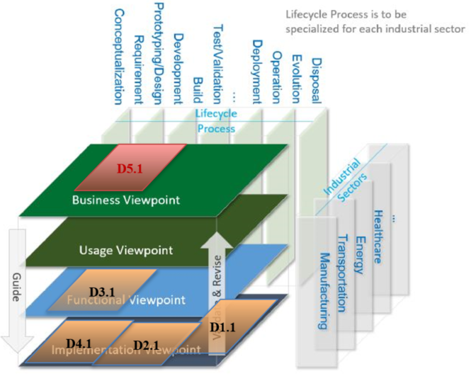

Figure 1. MS1 deliverable mapping to a common set of viewpoints

The following sections define the UC specification and high-level requirements. Section 2 describes the intricacies of the avionics UC, which is based around the aircraft cyber-blackbox. This section also considers the potential entry point for the developing AI algorithms into the UC. Similarly, section 3 presents the automotive UC and its intended development through utilisation of the state-of-the-art driving simulator. Section 4 provides a high-level overview of the project’s industrial requirements. Section 5 looks into tailoring of the proposed technology bricks to fit defined requirements. That content is resulting from the initial activities of T5.2, *Tailoring and specification of TEACHING technology bricks*. The intention here is not to blindly follow a set of rigid requirements, but to have a more fluid interaction between the UC needs and the practical exploitable solutions. The concluding section briefly wraps up the main findings of WP5 activities to date.

# The avionics use case

This case study focuses on safety and security monitoring of an avionics application. It targets autonomous detection and classification of unexpected system behaviour. The intention is to assemble an effective mitigation strategy, which results in a set of suggestions for the pilot. Those are then to be either approved or modified and acted upon. Alternatively, the person in charge of the system, i.e. the pilot, may also decline the proposed mitigation strategy. This interaction, between the machine and the pilot, places the human into the loop of the system as a form of improving the system safety and security monitoring.

## Flyance FMS – Overall specification & requirements

Modern planes are equipped with Flight Management System (FMS). Its purpose is to provide the crew with centralised control for the aircraft navigation sensors, computer-based flight planning, fuel management, radio navigation management, and geographical situation information. The purpose of the Flyance is to mimic the FMS that is used in modern avionics.

## Functional Description

As depicted in Figure 2, the FMS is responsible for services that allow in-flight guidance of the plane. Throughout the pre-set flight plans, starting with the airport take-off and finishing with the airport landing, the FMS is responsible for plane localisation and trajectory computation. It is FMS that enables the plane to follow the flight plan, and reaction to pilot directives. The FMS application is constituted by 25 time-critical tasks that are regrouped as presented in Figure 3.

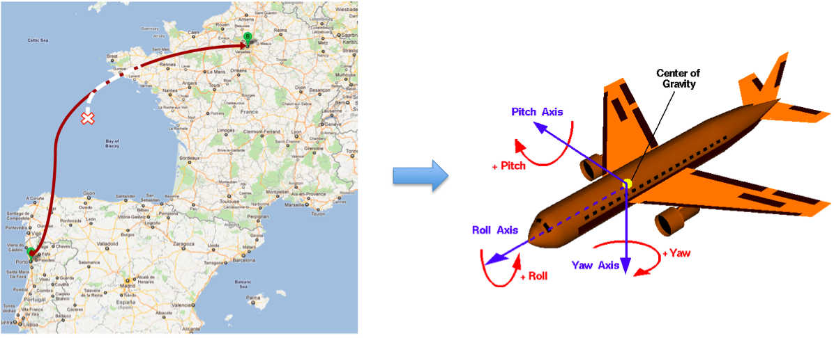

Figure 2. Flyance Flight Management System

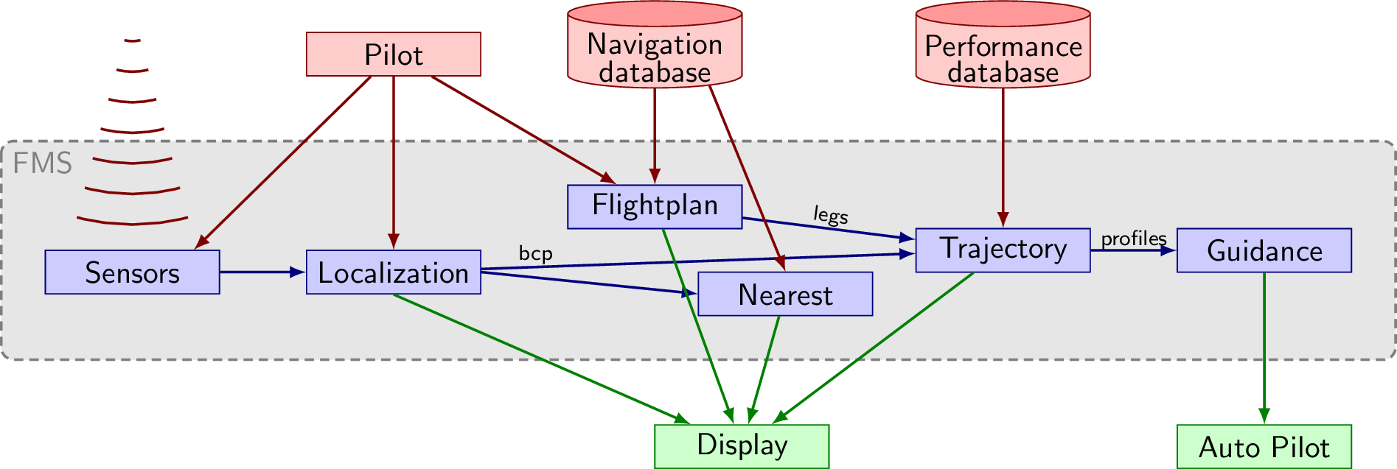

Figure 3. Flyance FMS - functional overview

The **Sensors task group** is in charge of generating all the localisation data from various sensors (Anemo-barometric sensors, Pure Inertia Reference System (IRS), Global Positioning System (GPS), Hybrid Inertia Reference System (HYB), Doppler sensor).

The **Localisation task group** is in charge of analysing outputs of sensors to generate the most probable position of the aircraft (BCP). This localisation data is composed of: Position (latitude, longitude, and altitude), Attitude (Pitch, Roll and Yaw angular rates), Velocity (Ground speed and Vertical Speed), Acceleration (lateral and longitudinal), and Wind-related data (speed and angle).

It must be noted that a single sensor may not provide the full localisation information. For instance, the Doppler sensor does not provide any position-related information, such as longitude and latitude. However, it provides very accurate velocity (speed-related) information. The role of the localisation task group is therefore to merge information from sensors with different trustworthiness levels.

The purpose of the **Nearest Airports task group** is to continually build a list of the nearest airports, during the flight. This information is useful if the pilot decides to land the plane impromptu. The tasks from this task group do not participate directly in flight management. The computed output is only sent to the display.

The **Flightplan task group** manages and processes modification requests on the pre-set flight plans. These are pre-set routes for plane guiding. Three different flight plans coexist concurrently in the system: 1) The active flight plan is the flight plan currently used to guide the aircraft; 2) The secondary flight plan is an alternative route toward the destination. It could consider an alternative landing runway at the destination airport, which has a significant impact on the target airport approach procedure; 3) The temporary flight plan is an intermediate flight plan, which allows the crew to enter a new flight plan and check for modification before applying. The flight plan task group is only composed of aperiodic tasks that correspond to the pilot’s modifications to the pre-set flight plans.

## Implementation details

The Flyance FMS is a C++ application relying on object programming. As a consequence, it has a significant text segment. The data transmitted between the 20 periodic and aperiodic tasks are stored in dedicated, software-defined structures, but the amount of data being transferred remains quite low (usually 3KB for inter-task data transfers).

Flyance also embeds a larger (10MB) navigation database, that is periodically accessed linearly to determine the list of the closest airports, computing loxodromic distances.

The most computation-intensive part of Flyance is its trajectory computation. However, the computation effort depends on the shape of the trajectory, with more computation during curves than during straight lines.

## Avionics Safety and Security

Detailed safety requirements of the avionics domain are presented in Section 4.4.3.2 of Deliverable D1.1. It introduces the **Design Assurance Level** (DAL) as the different safety levels defined by the avionics standards (DO-178, DO-254, DO-297). To ensure safety constraints, the industry relies on strict spatial partitioning and temporal partitioning, as well as the ability to compute the **Worst-Case Execution Time** (WCET) to respect real-time constraints.

A particular challenge for multi-core or heterogeneous architectures is to deal with **timing interference** of co-running independent applications sharing the same hardware resources (caches, interconnects, etc.). As a consequence, there is a tradeoff between performance and predictability. Hence, it is now required to identify and bound all the interference channels of the hardware architecture.

Avionics systems have already been federated for a long time. It is the recent increase in connectivity that adds to the existing concerns. Although the ability to perform post-mortem analysis has been perfected in the avionics industry for a while, the cybersecurity concerns are quite recent additions to this complex activity. These systems are currently mostly federated with very limited and precisely controlled connectivity solutions. Next-generation avionics is considering to largely increase the connectivity aspect, and the SESAR European initiative even considers the ability for the Air Traffic Management (ATM) to pilot the plane remotely around airports to increase traffic density. As a consequence, **cybersecurity** is becoming a prime concern in next-generation avionics systems, as well as the ability to Identify, Protect, Detect, Respond and Recover from security threats.

## Target Hardware for the avionics use case

Loxodromic computations are based on complex floating point and trigonometrical computation. The target hardware demands the usage of an embedded Floating Point Unit (FPU).

The Flyance embedded software sends some data over a UART channel to a x86-based graphical display running on a PC host. Consequently, the target hardware platform should embed a UART controller and should offer a UART interface. An additional UART controller is desirable for debugging purposes.

## Opportunity for AI

As **autonomous piloting** has been in its existence for decades in the avionics industry without relying on AI algorithms, there is a certain level of resistance to indroduce such algorithms to autonomous piloting. These algorithms are generally not considered by the avionics standards and there are no specific rules on how to certify such algorithms; the prime concern of being able to perform post-mortem analysis is in contradiction with the lack of explainability on how deep neural network, in particular, are computing the correct solution.

However, **monitoring** is also an important part of the safety process, where it can detect and correct errors on the fly, detect failures and start safety-related procedures to fail back to a nominal state as quickly as possible, etc. Such systems could be separated into two categories. From the perspective of safety, **Health Usage and Monitoring Systems** (HUMS) utilise data collection and analysis techniques to help ensure availability, reliability and safety of the aircraft systems, whereas, on the security side, **Host-based Intrusion Detection Systems** (HIDS) monitor malicious activity or policy violations to detect intrusion or cyber-attacks.

This monitoring activity would benefit from an introduction of AI-based algorithms, without impacting the ability to certify autonomous piloting. In the TEACHING project, the avionics use-case is considering the addition of an AI-based **cyber-blackbox**, whose role is to ensure the nominal and normal behaviour of the software on the hardware.

## Cyber-blackbox in a nutshell

### Functional description of the cyber-blackbox

The role of the cyber-blackbox is to ensure the correct behaviour of the autonomous piloting software (the Flight Management Software or FMS) on the hardware CPSoS. Figure 4 below is presenting the different components involved in the cyber-blackbox.

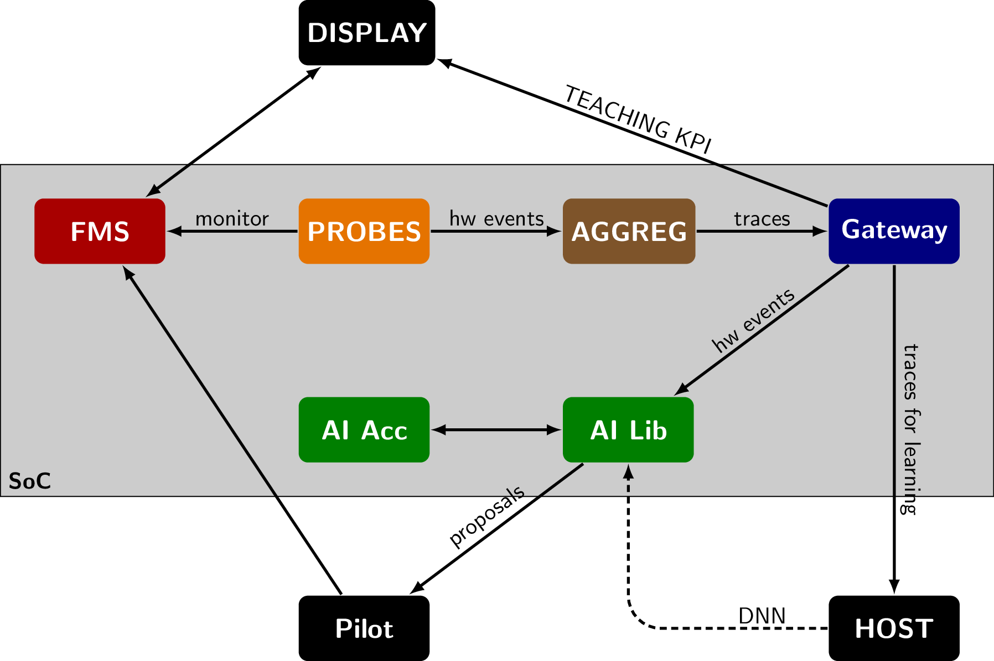

Figure 4. Cyber-blackbox components

Beyond the flight management systems appearing in red, specific requirements of which are detailed in Section 4.1 of this document, the cyber-blackbox is composed of:

* Probes: The probes aim to collect behavioural information at the hardware level. Most of the probes rely on the usage of performance monitoring counters, as well as specific probes such as SoC-level temperature probes.
* Aggregation: The role of the aggregation is to structure all the information collected by the probes into traces of hardware events.
* Gateway: The gateway purpose if to forward the previously generated traces to the proper target. During the learning phase that is performed offline, the traces are likely to be sent to an external host that would be performing the learning and build the corresponding deep neural network of a nominal behaviour of the application on the SoC. During the inference phase, the traces should be kept inside the SoC to assess the current behaviour against the previously built Deep Neural Network (DNN).
* AI algorithms: The AI algorithms perform the assessment and demand higher performance than usual safety-critical systems from avionics. AI algorithms can also be run partly on traditional cores (AI Lib), and partly on dedicated accelerator hardware (AI Acc).

The embedded CPSoS is also connected to different external systems, including:

* Display: A mark-up display application will be provided together with the FMS application to observe the actual position of the aircraft. This display will also serve to provide TEACHING-specific KPI, such as how well the AI algorithm is performing with regards to safety or security events.
* Computation Host: The external computation hosts are in charge of the learning phase of the AI algorithms. They are possibly placed in the cloud for elasticity and have to deal with large (several GB) traces of hardware events to characterise the normal behaviour of each application on the hardware.
* Pilot: The purpose of the AI algorithms is to detect anomalies with regards to the software behaviour on the hardware. These anomalies are provided as alerts to the pilot with possible mitigation proposals. It is up to the pilot to decide which mitigation solution to apply by interacting with the FMS.

### Mapping the cyber-blackbox on the target hardware

Both the flight management system and the cyber-blackbox are being mapped to the target hardware board provided by I&M. The hardware includes an Aurix Tricore carrier board connected to an ARM-based NXP iMx8 socket on module.

Mapping the different components of the cyber-blackbox to this hardware requires consideration of each component requirements in terms of performance and connectivity while minimising the potential timing interference with the safety-critical real-time application that is the Flight Management System.

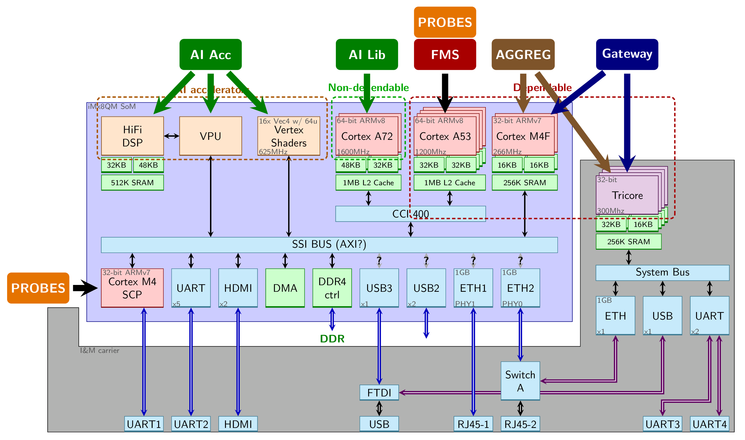

Figure 5. Mapping of the cyber-blackbox on the I&M target hardware

This platform is composed of three **dependable** core sets: The Aurix Tricore from the carrier board, the ARM Cortex M4 cores from the iMx8 SoM and the Cortex A53 cores from the iMx8 SoM. It also embeds some ARM Cortex A72 **high-performance non-dependable** cores, as well as a General-Purpose Graphics Processing Unit (GPGPU) **accelerator**.

Possible mappings are presented in Figure 5:

* FMS: Ideally the Flight Management System would be run on the most dependable cores being either the Tricore or the Cortex M4. But the FMS also requires to access a several megabytes-large navigation database that requires to be stored in memory. The only option is, therefore, to map the FMS on the Cortex A53 cores that provide a sufficient level of performance as well as the required memory space.
* Probes: Most of the probes that are relied upon by TEACHING, are the Performance Monitor Counters (PMC) that are private to each core. Hence, the Probes must on the same cores as the FMS. While doing so, one must minimise the timing interference induced by the Probes component on the FMS. On the iMx8 in particular, some power, voltage, energy and temperature probes are available at SoC-level through a dedicated SCP core. This core is not directly programmable, and it requires to implement a specific protocol to gather this information.
* Aggregation: For aggregation, there is a compromise on interference. The aggregation could be performed on the Cortex A53 cores, and therefore interfere with the memory usage/ Alternatively, the aggregation is performed on smaller cores (Cortex M4 or Tricore) but it involves inter-core communication that itself could be the cause of timing interference. Ideally, this aggregation could be performed on the Tricore; the price for which is higher communication cost, being outside of the SoM. If the penalty is hampering predictability, the aggregation will be mapped to the Cortex M4.
* Gateway: The gateway suffers from the same requirements as the aggregation, additionally requiring external communication mediums to the host or the cloud. It would make little sense not to map the Gateway at the same location as the Aggregation, as such mapping would cause additional internal communication.
* AI Lib: The trace analysis part using AI algorithms and libraries should not be run on the Cortex A53 due to the shared L2 cache that would involve a significant amount of timing interference. The Cortex A72 cores, providing a higher performance level with a separated L2 cache is a good candidate, limiting timing interference to DDR level accesses.
* AI Acc: The AI accelerated kernels should ideally run on the GPGPU accelerator, but the Cortex A72, considered as an accelerator, could be sufficient to run the inference part of the DNN algorithms.

# The automotive Use Case

The current automotive transformation is supported by the trend of automated driving (AD). The advancements are compatible with other trends (electrification, connected vehicle, diverse mobility etc). The expected benefits include increased road safety and improved driving comfort. The AD implementation is ranked according to the available level of automation in the vehicles (Figure 6) [1].

1. 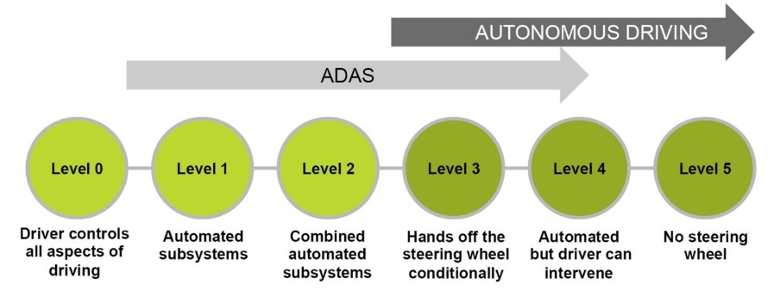

Figure 6. From ADAS to autonomous driving

A vehicle convoy function (depicted in Figure 7) is heading in the direction of automation and is improving two important aspects, safety and contact within an autonomous and safety-critical system. Convoy function is a complex driving scenario linked to highway platooning. The UC scenario is based on the lead vehicle being followed by other vehicles, all of which rely on the exact functional operation and user acceptance based on human perception of safety. The perception is the decisive factor for the driver’s acceptance and ability to take over control from the autonomous driving system. The system functions seek cooperation between autonomous (safety-critical) CPSoS, IoT and vehicle’s advanced control strategies. The cooperation also relies on: accurate positioning of the ego-vehicle and the leading vehicle; velocity profile and planned trajectory of the leading vehicle; information on human behaviour for user acceptance and transition scenario in Level 3 / Level 4 autonomous driving, where human needs to be in the position to take back control over the vehicle. The combination of the above functional interactions stresses the challenge of creating a reliable solution for autonomous and safety-critical distributed systems of networking computing elements and humans in the autonomous driving context. The aspects of energy-efficiency, dependability, cyber-security and support for multi-criticality are hence of crucial importance.

1. 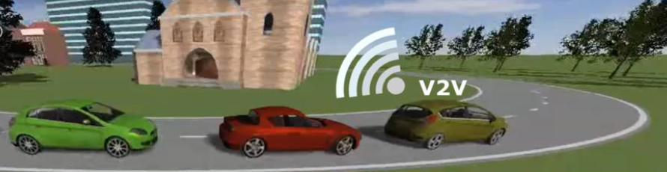

Figure 7. A vehicle convoy scenario

## Highway platooning – functional overview

User-centric aspect is in the main focus of the UC. To that extent, a set of in-vehicle sensors is required to firstly detect the presence of humans in the vehicle, but also to determine their physiological parameters (e.g. blood pressure, heart rate (HR) and heart rate variability (HRV)). The raw sensor data is to be interpreted using a set of algorithms perfected in the TEACHING project. These are to build upon the existing set of algorithms that are already in use at the proposed driving simulator of section Driving simulator3.4. Their focus is placed on determining the stress level of vehicle occupants and classification of driver performance, based on the measured physiological parameters. The quantified stress levels are then informing the vehicle controls of manoeuvres that would be acceptable for the vehicle occupants. Alternatively, an appropriate strategy must be devised to deal with estimation of driver preparedness for a driving takeover, as well as the execution of that takeover strategy. In alignment with the need for such an action, it is expected that vehicle HMI is capable of providing appropriate visual, auditive and haptic means of interaction.

## Safety aspect

The most appropriate safety standard for the given application is ISO 26262:2018 (Road vehicles — Functional safety) [2], which is an international standard for functional safety of electrical and/or electronic systems in serial production road vehicles. This is not the only relevant standard, as it should be complemented by other dedicated application-specific safety standards. It is a part of TEACHING project to also determine the most appropriate combination of standards to adhere to if implementing the proposed functionalities to the safety-critical CPSoS. That is primarily concerning the autonomous driving application, which is specifically constrained by the requirements to operate on highway scenario related to a defined Operational Design Domain (ODD) for platooning use case.

The currently identified applicable documents that could support the safety considerations are:

* ISO 26262 Road vehicles [3] — Functional safety
* ISO 21448 Road vehicles [4] — Safety of the Intended Functionalities
* SAE J 3016 – Driving Automation Taxonomy
* SAE J3164 - Taxonomy and definitions for Terms Related to Automated Driving System Behaviors and Maneuvers for On Road Motor Vehicles
* ISO/DTR 4804 – Road vehicles – Safety and cybersecurity for automated driving systems – Design, verification and validation methods
* On a Formal Model of Safe and Scalable Self-driving Cars – Mobileye 2017

To support the management of the standardisation concept phase, an item definition is compiled.

### Item definition

The item definition for the automotive UC includes:

* On-board and/or wearable sensors
* Human Comfort/Stress Model
* Personalisation (Training & Inference)
* Environmental Sensors

The online learning is based on feedback provided through observation of the human in the loop to feed a vehicle’s automated driving algorithms with the information that is based on the comfort levels of the passengers and the driving policy. The completed item fulfils the task of safe changing between manual and different automated driving modes. For the activation of an automated driving mode, the necessary information must be obtained to check if all the prerequisites such as the ODD are fulfilled (e.g. whether the automated vehicle is on the correct road type, check the weather conditions etc.).

Moreover, the triggering of the mode changing may be based on the vehicle state or state of the human driver, which are determined by on-board or wearable sensors respectively. Therefore, based on the information from one or more monitors, and on the interpretation and prediction data of the environment surrounding the vehicle, the item can decide, strategically, whether to initiate an ODD functional adaptation or apply a Minimal Risk Maneuver to reach a Minimal Risk Condition through the Decision-Making Unit (DMU). The DMU (out of item) takes care of the path planning to decide the proper trajectory in the manoeuvre.

The communication network provides the required availability and integrity depending on the item, thus supporting the automated driving capabilities. A high diversity communication network for both nominal and degraded elements is met. The communication of data among the elements of the item is performed through SPI, SMI, I2C protocol, while communication with the external interfaces is performed through ETHERNET and/or CAN protocol. Further protocols for the environmental sensor data could be used. These depend on the available sensor technology (e.g. GMSL, RGMII).

With reference to Figure 18, the item elements “On-board or wearable sensors” and “Human Comfort/Stress Model” are out of the scope of ISO 26262, as they are not safety-related elements. It is assumed that output data from these elements are valid as input for the safety-related element “Personalisation (Training & Inference)”.

### Potential consequences of shortfall behaviour

Erroneous subsystem output values or low confidence values can lead to potentially hazardous behaviour. These include, but are not limited to, the following:

* incorrect classification,
* incorrect measurements,
* incorrect tracking,
* misdetection,
* ghosts,
* incorrect target selection,
* incorrect kinematic estimation,
* occluded areas, etc.

A potential “personalisation” different or not plausible from the expected one, caused by not validated item output, could lead to an unwanted vehicle behaviour in terms of the manoeuvre actuation, regardless of the set points being defined a priori in the driving policy. Hence, path planning errors could produce inappropriate control command requests and therefore several hazardous events within the same highway scenario.

### Classification of objects and hazards

Objects and hazards should be classified if wishing to provide a correct interpretation and a prediction of the environment surrounding the vehicle. The classification should be made within the field-of-view of the complete sensor setup, or a subset thereof. Any classification should also include the confidence level for the estimated class.

Examples of classes include:

* Other road users, such as cars, motorcycles, buses, and trucks
* Vulnerable road users, such as pedestrians and bicycles
* Animals
* Road works or construction areas
* Road geometry and boundaries, e.g. guard-rail detection, road surface, lane marking, and curbs
* Road sign/traffic sign
* High and low beam, turn signals and brake signals
* Unidentified objects (stationary targets and moving targets)

### Operating conditions and ODD

The following operating conditions list takes care of the main safety-critical conditions, assumed for the item operating within its own ODD. These are considered as a basis for the safety by design and the validation activities.

Table 2 Automotive operating conditions

|  |  |  |  |
| --- | --- | --- | --- |
|  | **Parameter** | | **Values** |
| **Locality** | Location | | Highway |
| Road Condition | Adherence | Dry friction conditions |
| Road Surface | Asphalt |
| Slope | +-2° |
| Route | Highway 3 lanes circle |
| Scenario/Traffic Situation | | Medium traffic |
| Other characteristics | | - |
| **Driver/Vehicle** | Dynamic Driving State | Vehicle Speed | 60-130kph (+-15kph) |
| Longitudinal acceleration/ deceleration | Up to 6m/s² |
| Lateral acceleration | Up to 6m/s² |
| Key status | On |
| Engine Status | Ignition On |
| Use Case description | | Vehicle driving in a one direction only road (3 lanes maximum) with medium other traffic. Changes of environment happen to occur in random timing e.g. (Vehicle-Cut-Ins/Outs, Speed limits, lane merges or construction sites). The vehicle is driving in L3 condition (driver is always monitoring) and the personalisation block does adopt the L3 driving function due to the driver state. |
| Driver presence (L3 level of driving automation or L3+) | | Driver in the loop |
| Other Characteristics | | - |
| Persons at Risk | | | None (simulator) |
| Weather conditions | | | Good - average |
| Light conditions | | | Good - average |

### Standards & Regulation requirements

Table 3 sums up the preliminary list of the standards, regulations and guidelines, to be considered and applied to the defined items. For further details, please refer to D3.1.

Table 3 Standards, regulations and guidelines relevant for defined items

|  |  |  |  |
| --- | --- | --- | --- |
| **Agency** | **Regulation/ /Standard #** | **Name** | **Applicability** |
| UNECE | R157 | Proposal for a new UN Regulation on uniform provisions concerning the approval of vehicles with regards to Automated Lane Keeping System | States which signed the Agreement 1958 UNECE |
| EU Commission |  | Guidelines on the exemption procedure for the EU approval of Automated Vehicles. | EU States |
| ISO | 20035 | ITS- Cooperative Adaptive Cruise Control System (CACC) Performance requirements and test procedures | worldwide |
| IEC | 62508 | Guidance on human aspects of dependability | worldwide |
| EU |  | Ethics Guidelines for Trustworthy AI, 2019 | EU States |
| EC |  | Whitepaper On Artificial Intelligence | EU States |

### Driving Policy

Planning, commonly referred to as “driving policy”, yields strategic (i.e. change lanes) and tactical (i.e. overtake the car) driving decisions. Creating a driving policy that ensures driving in a collision-free manner without compromising comfort or traffic flow is the task of the DMU (Figure 18). Driving policy or Nominal Safety is the concern of whether the automated vehicle (AV) is making safe logical decisions, assuming that the HW and SW systems are operating error-free (i.e. are functionally safe). A promising solution lies in defining formal rules, such as a theoretical approach and hierarchical sets of rules. These formal rules may include, but are not limited to, the following:

* Explicit traffic rules:
  + Conform to all applicable traffic rules within the ODD that the automated vehicle is operating in, taking regional differences in traffic rules into special consideration. Roads, signalling elements and other infrastructural objects are the physical embodiment of the explicit traffic rules, e.g. a STOP sign or double solid lane marking.
* Implicit traffic rules:
  + Maintain a safe longitudinal and lateral distance from other objects to avoid the collision.
  + Right of way is given, not taken. Following, the safety-first principle, non-compliance of other road users with traffic rules are expected and dealt with defensively.
  + Be cautious in areas where other road users may be occluded. If information from interpretation and prediction, the ODD, or other sources indicates that there is a potential for occluded objects, the automated driving system is prepared for the possible sudden appearance of other road users.
  + If it is possible to perform a legal and safety-assured manoeuvre to evade a potentially unsafe situation, then the automated driving system is doing so.
  + If it is not possible to evade an unsafe situation without prioritising the traffic rules, then it may be possible for the automated driving system to prioritise traffic rules while making a safety-assured manoeuvre.

### Item Data Flow Diagram

The item can be described in the form of a Data Flow Diagram (DFD). It represents the flow of data for an item. The DFD provides information about the outputs and inputs of each entity and the process itself. A DFD has no control over the flow, there are no decision rules and no loops.

Processes are the essential activities that use the information and are carried out within the system boundary. A process is represented in the model only where the information which provides the input into the activity is manipulated or transformed in some way so that the data flowing out of the process is changed compared to that which flows in.

Data-flow represents a package of information flowing between two objects in the DFD. Data-flows are used to model the flow of information into the system, out of the system, and between elements within the system.

Data store is a place where data is stored and retrieved within the system. This may be an external entity.

External entities are entities outside of the system boundary which interact with the system, in that they send information into the system or receive information from it. External entities may be external to the whole organisation as in Customer and Supplier; or just external to the application area where users’ activities are not directly supported by the system under investigation.

An idem DFD is depicted in Figure 8, where the blue processes define the item perimeter whereas the orange process is an external process to the item. The safety-related processes within the item perimeter have their outline coloured in red. These processes must comply with current safety standards and regulatory requirements. The external processes to the item are excluded from the safety consideration in this case.

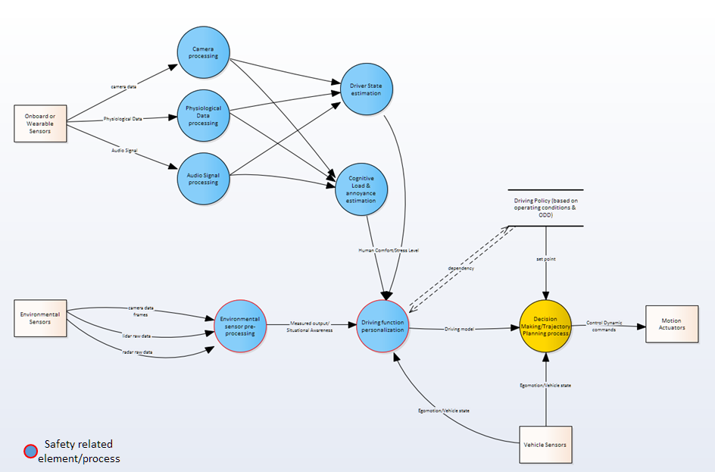

Figure 8. An item DFD

### Item interaction

The main item interactions are with the following external systems:

* **Ego-motion/Vehicle State** describes the actual state of the vehicle in terms of yaw rate, longitudinal acceleration, lateral acceleration etc. Further values describing the vehicle state may include vehicle speed or slip angle. Some of the data can directly be measured using an inertial measurement unit, wheel ticks or derived from other sensors such as cameras.
* **DMU** plans the navigation trajectory to actuate the manoeuvre selected on longitudinal and lateral vehicle motion control. The selection of the appropriate manoeuvre is based on the operating environment, ODD, and the vehicle state.
* **Motion Actuators**, which are within the controller in the Co-Simulation environment:
  + Electric Power Steering (EPS) expects to receive (CAN bus) the steering command for the steering torque actuation according to the planned trajectory.
  + Brake System Module (BSM) expects to receive (CAN bus) the brake command for the braking actuation according to the planned trajectory.
  + Traction Control Unit (TCU) expects to receive (CAN bus) the gear engagement command for the forward drive torque or neutral gear engagement according to the planned manoeuvre.
  + Engine Control Module (ECM) expects to receive (CAN bus) the throttle command for positive torque actuation according to the planned trajectory.

### Boundary definition

Table 4 lists the Sub-systems Under Safety Analysis (SUSA). The ‘role’ differentiates between the elements that are within the technical scope of the project (‘Involved’) and the ones that are needed for demonstration but are not being developed within the projects (‘Interface’).

Table 4 Sub-systems Under Safety Analysis

|  |  |  |  |  |
| --- | --- | --- | --- | --- |
| **Id#** | **Element** | **HL Function** | **Description** | **Role** |
| 01 | Environmental Sensors | Lidar pre-processing | This function processes the raw (measurements) data from each Lidar sensor to perform:   * Lidar acquisition * Lidar noise data filtering * Lidar calibration | Involved |
| Camera pre-processing | This function processes the data frames from each Camera to perform:   * Camera acquisition * Camera noise data filtering * Camera calibration * Camera occlusion report * Camera visibility range report | Involved |
| Radar pre-processing | This function processes the raw (measurements) data from each Radar sensor to perform:   * Radar acquisition * Radar noise data filtering * Radar calibration | Involved |
| 02 | Personalisation (Training & Inference) | Driving function personalisation | This function considers the inputs of 03 and in combination with the learned data of the actual driver estimates how the driving function shall be adapted   * To get better feedback out of the human comfort and stress model * To incorporate the feedback of 03 | Involved |
| * + - * 1. 03 | Human Comfort/Stress Model | Driver State estimation | This function estimates the driver state from the input 04 | Involved |
| Cognitive Load & annoyance estimation | This function estimates the driver state (cognitive load and also the annoyance) from the input 04 | Involved |
| * + - * 1. 04 | Onboard or wearable sensors | Camera processing | This function processes the raw camera data to perform:   * Gaze classification * Driver state estimation * Head pose detection * Facial Landmarks * Driver identification | Involved |
| Physiological Data Processing | This function provides biological sensor data as input for the human comfort and stress model (incl. HR and HRV etc.) | Involved |
| Audio signal processing | This function provides input for human comfort stress model | Involved |
| 05 | Decision Maker Unit | Manoeuvre selection | This function selects the appropriate manoeuvre to plan the trajectory based on the operating environment and vehicle position. The manoeuvre also depends on ODD and item-health status. | Interface |
| ODD exit manoeuvres (fallback strategy) | This function performs the ODD exit manoeuvre if the operating conditions are outside the ODD limit. The fallback planning is required to notify the driver by warning or request the take-over control. | Interface |
| Trajectory planning | This function plans the navigation trajectory and provides the vehicle longitudinal and lateral command to actuate the selected manoeuvre | Interface |
| 06 | Vehicle sensors | Ego-motion/Vehicle State Monitoring | This function provides the actual state of the vehicle in terms of yaw rate, longitudinal acceleration, lateral acceleration and more. Some of the data can directly be measured using an inertial measurement unit, wheel ticks or derived from other sensors such as cameras | Interface |
| 07 | EPS | Steering actuation | This function requires the steering command request by DMU to provide the actuation. | Interface |
| 08 | ECM | Throttle actuation | This function requires the throttle command request by DMU to provide the actuation. | Interface |
| 09 | BSM | Brake actuation | This function requires the brake command request by DMU to provide the actuation. | Interface |
| 10 | TCU | Gear engagement | This function requires the gear engagement command request by DMU to provide the actuation. | Interface |

## Security Aspect

By intensifying the usage of connectivity features for AD, the risk of cyber-attacks is amplified. The newly introduced cyber-security risks are attracting a range of mitigating strategies across the automotive field. Hence, there is a demand for solutions to protect shared information, as well as to offer a standardisation outline to be adhered to while developing AD functions [5].

To that aim, in terms of technical developments, there is a need for an edge-oriented and federated computational environment that seamlessly integrates heterogeneous resources comprising specialised edge devices, general-purpose nodes and cloud resources. TEACHING concept relies on the development of specialised HW to run AI, cybersecurity and dependability components. The proposed HW platform (Section 5), is to integrate the methods that support runtime dependability assurance of CPSoS. These are then to be tested (in a safe environment) on the driving simulator (of Section 3.4).

The developed methods should be also supported by novel engineering processes, which are to come hand in hand with the design of conventional and AI-based runtime adaptive systems tailored towards a cognitive security framework. The processes and their resulting security mechanisms will be tested in terms of prevention of unintentional (e.g. HW/SW faults) or intentional (e.g. jamming attacks) errors to ensure safety and security of the CPSoS.

## Driving simulator

The existing driving simulation (Figure 9) enhances the TEACHING study by providing the possibility to integrate human into the control loop, as well as offering the chance to test the AI algorithms in a safe, but realistic environment. The simulator is placed in a controlled laboratory environment. The hexapod simulator integrates a driver cockpit, which is cut out of a real vehicle, and a 180° projector canvas for visualisation of the environment and driving scenarios. A high frame rate of projections minimises the driver disturbance and reduces the proneness to motion sickness, which occurs to roughly a quarter of participants. The rear-view mirrors and the side views are simulated to improve awareness of the virtual environment through an increased field of view.



Figure 9. Driving Simulator

The motion system, characterised by six degrees of freedom, offers plenty of manoeuvring possibilities, as required for simulation of following motion types: longitudinal, lateral and vertical translational and pivoting around each axis. The available translational and rotational accelerations provide adequate movement for low-dynamic ADAS scenarios.

Drivers are monitored and their biometric data is recorded with the help of a range of sensors. The exact combination of sensor types varies for different studies, subject to the topic of the study and availability of improved sensor capabilities. Sensor data is logged at the format that suits each sensor with the appropriate sampling rate. Where possible, the data is collected in a synchronised format. An additional source of (subjective) information is obtained through participant questionnaires.

A co-simulation framework, with integrated AD functions, interconnects a range of software and hardware to facilitate the usability of all necessary components. The framework also offers a possibility to simulate scenarios that are unlikely to be tested in real driving situations, due to the safety concerns for the vehicle occupants and other road users.

# Use Case Requirements

The use case requirements are devised from the avionics and automotive perspectives (T5.1). However, instead of preserving a rigid set of requirements and demanding a fixed path for the development of the technology output from WP2 – WP4, these are consolidated (where possible) and tailored (T5.2) for ease of integration of technology outputs into the demonstrators (T5.3). The requirements are collected in a shared .xls format. The current version of the document ([Project requirements document release 1.0](https://unipiit.sharepoint.com/:x:/r/sites/TEACHING/Shared%20Documents/Requirements_project/Teaching_requirements_Release1.0_20201222.xlsx?d=w4dd4dacd656b46eab1087f5ed643d678&csf=1&web=1&e=e3AJew)) is frozen for use by this and associated deliverables and for the sake of the first project milestone. However, the requirements document is treated as a live document enabling reasonable updates. In that sense, the process allows integration of the feedback and lessons learnt from the TEACHING activities. The intention is to enable maximal usability of the generated project assets instead of performing a strict following of the initial set of requirements. Such a process maximises the potential for the facilitation of benefits to the full range of stakeholders.

To ease the collection of the requirements, the process is focusing on the most important aspect and not resourcing to full-scale requirement engineering processes.

The collected requirement fields are:

* ID – needed for tracking
* Creator – TEACHING partner
* Title
* Description
* Priority – low/medium/high
* Source of the requirement – task/deliverable
* Level – high/low
* Requirement layer – Use-case / Safety-Critical / Real-Time
* Link to requirement(s) (optional)
* Web-Link/Reference/Additional Information
* Impact on WP1 – WP5
* Means of verification (KPI)

The rest of this section summarises the main points of the collected requirements from the perspective of each use-case.

## Avionics: Flyance FMS - Task-level specification & requirements

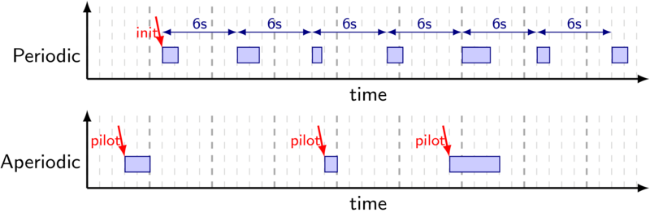

Figure 10. FMS task activation schemes

As shown in Figure 10, real-time requirements for the Flight Management System tasks are expressed by both activation schemes (synchronous and asynchronous) and task’s deadlines, might it be for periodic or aperiodic tasks.

Requirement: RTOS activation patterns

The real-time operating system is responsible for providing the required task activation patterns for both synchronous periodic and asynchronous aperiodic tasks. The RTOS is also responsible for detecting deadline misses associated with these tasks.

Requirement: Target hardware memory

The target hardware shall embed a sufficiently large amount of memory (~32MB) of memory for the navigation database, code text segment and FMS data. To minimise main memory accesses during task execution, and therefore minimise timing interference the hardware platform also requires to embed some local memories (private cache hierarchy or private scratchpad memories).

### Sensor task group

The actual position of the aircraft (BCP) is computed out of various sensors providing position and speed information such as Anemo-barometric sensors, IRS, GPS, HYB, Doppler sensor; as well as various radio navigation based systems such as VOR, DME and TACAN beacons.

It must be noted that none of those sensors is capable of providing full Localisation information. The Doppler sensor for instance does not deliver any position related information such as longitude and latitude. However, it is providing very accurate velocity (speed-related) information.

The optimal behaviour of some sensors is also prone to environmental conditions. For instance, the GPS sensor needs to receive a signal from at least four different satellites to triangulate a position. When it is unable to provide meaningful information, the sensors are sending some localisation data anyway, specially marked as being invalid.

Finally, as being physical devices sensitive to the environment, not all sensors generate their outputs with the same periodicity.

#### Periodic tasks

**SENSC1**: This unique periodic task is responsible for generating every sensor outputs to be passed to the Localisation task group. For the demo, this task will rely on trace files corresponding to the outputs of the different sensors.

Requirement: Periodic sensors real-time requirements

Every sensor outputs data are generated every 200ms (5Hz periodic task), with a deadline equals to the period. Those data can possibly partially or fully be marked as invalid, depending on the flight conditions.

#### Aperiodic tasks

The aperiodic tasks correspond to the possible pilot actions, such as deactivating or freezing a sensor, resting sensors parameters, and so on. The table below summarises the possible actions:

* **SENSA1** configures the anemo-barometric sensor, either manually setting the indicated air speed (IAS), the total air temperature (TAT), or more commonly setting the corrected barometric altitude (ZBC) as this probe provides very accurate altitude information as long as the ground pressure is set correctly (critical for landing operations).
* **SENSA2** is about GPS calibration. It performs the satellite selection/deselection, can hold, invalidate or force the GPS position.
* **SENSA3** deals with the inertial sensors, performing initialisation of the inertial probe, as well as holding, invalidating or forcing the value.
* **SENSA4** manages the Doppler sensor, selecting the surf mode, performing surface wind selection of sea current selection.

Requirement: Aperiodic sensors real-time requirements

New sensors parameters asynchronously set by the pilot should be taken into account in the next sensor operational cycle, implying a deadline of 200ms. Each aperiodic task from the sensor group could be triggered at a maximum of 2 times per the 200ms operational cycle.

#### Task communications

Figure 11 illustrates both the internal buffers of the Sensor task group, as well as internal and external communications.

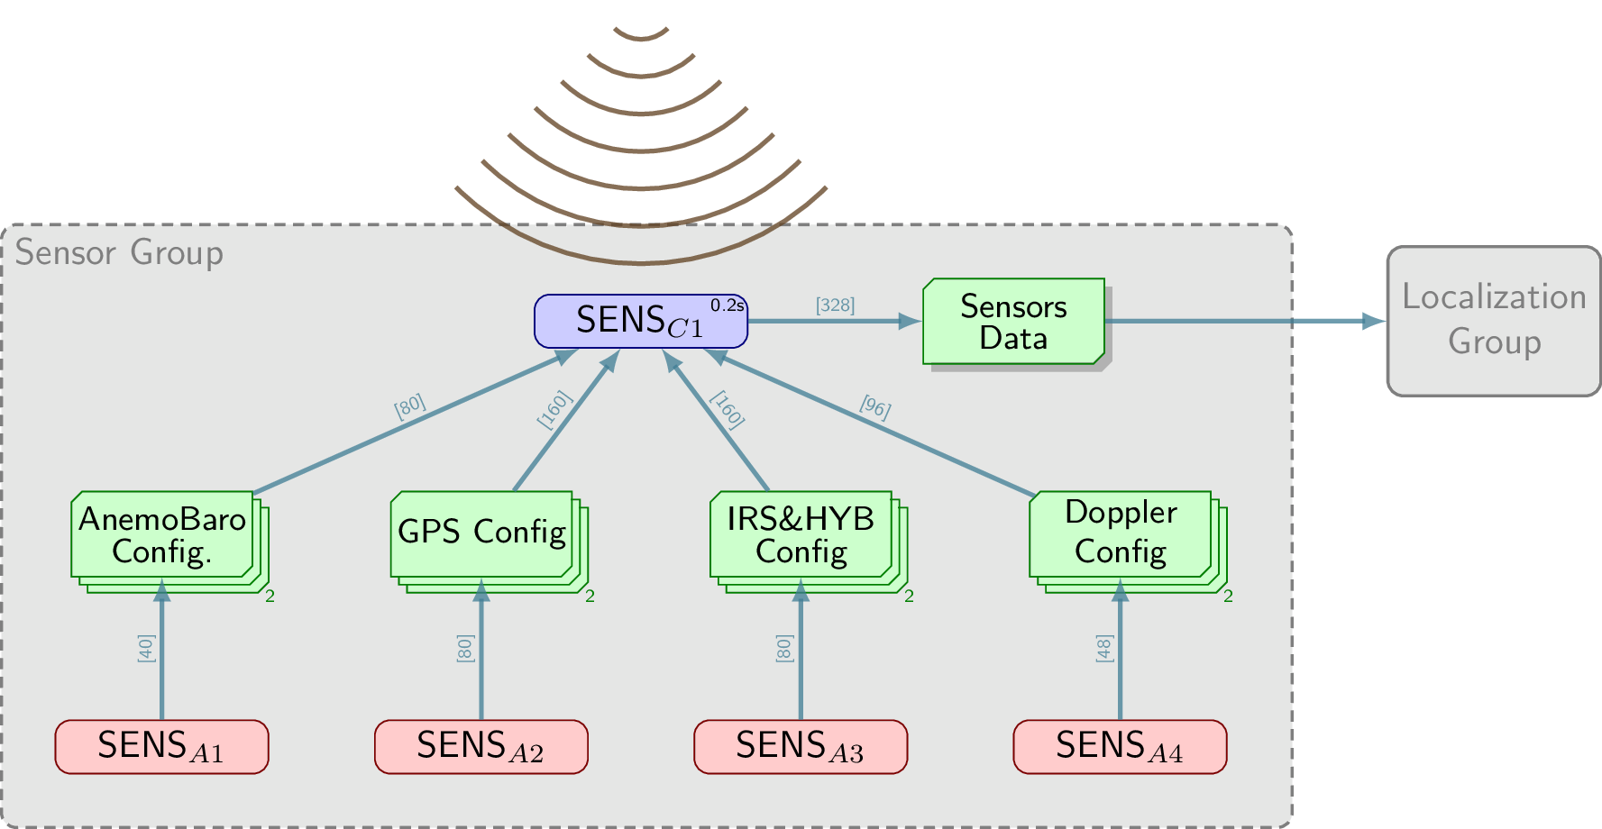

Figure 11. Sensors task group

**Internal communications**: Internal communications consist first of every asynchronous task writing to their dedicated buffers; and second of the generation of the sensor data by task SENSC1.

**External communications:** For inputs, the sensor task group mimics the sensors’ activity, reading sensors info from trace files and forwarding that information to the localisation task through the Sensor Data buffer. For outputs, the sensor task group is compounding each sensor’s output for them to be smartly merged by the Localisation task group.

### Localisation task group

The Localisation task group is in charge of managing sensors outputs to generate the most probable position of the aircraft (BCP). The **localisation data**, allowing us to specify the plane location decomposes in: position (latitude, longitude, and altitude), attitude (pitch, roll and yaw angular rates), velocity (ground speed and vertical speed), acceleration (lateral and longitudinal), and wind-related data (speed and angle). Mostly, all those data are stored as double-precision floating-points.

The localisation task group encompasses different running modes corresponding on the number of sensors available and the trustworthiness of the computed location, as well as different level of computational effort needed to compute the aircraft actual position (BCP):

* **Nominal:** All required input information available.
* **Degraded (speed):** No more position information available, but still speed information available.
* **Anemo:** No more ground speed information but still heading and air speed information available from the anemometer, as well as position information.
* **Anemo Degraded:** Only bearing and air speed information available, but no more location information available.
* **Position only:** Only position information available.
* **Invalid:** Insufficient data available.

The most time consuming mode (worst-case mode) is the nominal mode when all the sensor inputs are available, as sensor merging will be more complex. It is possible to characterise the worst-case execution times for the different running modes, providing finer grain timing analysis of this task group.

#### Periodic tasks

The Localisation task group decomposes into different tasks, as presented below:

* **LOCC1**: Sensor management and high frequency BCP processing: This task is responsible for merging the valid sensor data, for performing data fixing on some of the sensor information, managing the localisation running mode based on the number of available sensor information, and for starting the computation of the best computed position performing a weighted mean of sensor information.
* **LOCC2**: Low frequency BCP processing: This task is in charge of the low frequency processing associated with the best-computed position computation.
* **LOCC3**: Magnetic declination computation: This task is in charge of computing the angular difference between magnetic north and true north (magnetic declination).
* **LOCC4**: Performance computation: This task is responsible for computing the actual aircraft navigation performance (ANP) according to dynamic aircraft performance models.

Requirement: Periodic localisation real-time requirements

LOCC1 should operate as a periodic task at a cycle frequency of 200ms (5Hz) to match with sensors outputs. The low-frequency BCP needs to be computed by LOCC2 every 5000ms. The magnetic deviation has to be updated by LOCC3 every 1600ms. Finally, the performance is computed every 1000ms by LOCC4. All these tasks have a deadline matching their period.

#### Aperiodic tasks

Again, the aperiodic tasks correspond to the possible actions performed by the pilot, including updating the earth magnetic variation tables, setting the required navigation performance (country-based), …

* **LOCA1** is responsible for BCP updates, including forcing the localisation mode, freezing the current position, or repositioning the current position.
* **LOCA2** is about manually updating the magnetic variation tables, that is physically varying over time, especially when closer to the poles.
* **LOCA3** is setting the required navigation performance (RNP) that is defined by country my the avionics navigation authorities.

Requirement: Aperiodic localisation real-time requirements

New localisation parameters asynchronously set by the pilot should be taken into account in the next operational cycle of the related task, implying a 200ms deadline for BCP related, 5s for magnetic variation related, and 1s for performance related. LOCA1 could be triggered twice every 200ms, LOCA2 could be triggered 5 times every 5s and LOCA3 could be triggered 5 times every second.

#### Task communications

Figure 12 illustrates both the internal buffers of the Localisation task group, as well as internal and external communications.

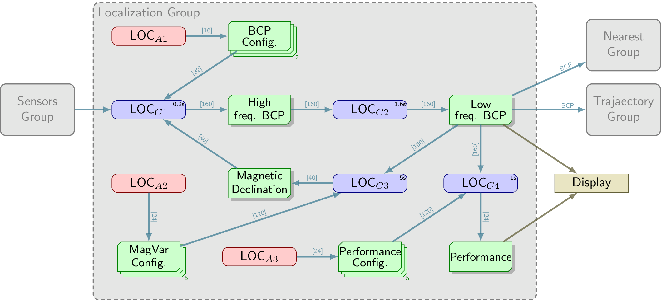

Figure 12. Localisation task group

**Internal communications**: First the configuration information set by the different pilot aperiodic tasks are filling corresponding buffers. Task LOCC1 is providing the pre-computed BCP information to task LOCC2 through the High freq. BCP buffer. LOCC2 is computing the fixed BCP into the Low Freq. BCP buffer, for this data to be reused by LOCC3 and LOCC4. LOCC3 is in charge of updating the Magnetic Declination buffer used to correct the LOCC1 computed heading. And finally, the task LOCC4 is generating the performance buffer to be displayed.

**External communications:** The input data of the Localisation task group corresponds to the output data from the Sensor task group. The output of this task group is the most probable aircraft position (BCP).

### Flightplan task group

The FMS system helps to guide an aircraft thanks to the computation of a trajectory based on a predefined flight plan. The Flightplan task is in charge of managing and processing modification requests on the flight plans.

Three different flight plans coexist concurrently on the system:

* The active flight plan is the flight plan currently used to guide the aircraft.
* The secondary flight plan is an alternative route toward the destination. It could consider for instance an alternative-landing runway on the destination airport, which has a significant impact on the target airport approach procedure but may become the only viable option under certain wind conditions.
* The temporary flight plan an intermediate flight plan allowing the crew to enter a new flight plan and check for the modification before applying. One of the roles of the pilot is to determine a new flight plan taking into account weather conditions to minimise fuel consumption and to avoid unnecessary risks.

#### Periodic tasks

The flight plan task group is only composed of asynchronous events corresponding to the management of the flight plans, or the alteration of existing flight plans.

#### Aperiodic tasks

The different pilot actions translate into aperiodic tasks modifying the different flight plans. Each aperiodic task is modifying a semaphore protected buffer corresponding to one of such flight plans:

* **FPLNA1** is initialising the active flight plan with waypoints from the navigation database.
* **FPLNA2** is making the second flight plan active, copying it to the primary active flight plan.
* **FPLNA3** is initialising the secondary flight plan with waypoints from the navigation database.
* **FPLNA4** is making the temporary flight plan active, copying it to the primary active flight plan.
* **FPLNA5** is initialising the temporary flight plan with waypoints from the navigation database.
* **FPLNA6** is managing/altering the primary flight plan.
* **FPLNA7** is managing/altering the secondary flight plan.
* **FPLNA8** is managing/altering the temporary flight plan.

Requirement: Aperiodic flight plan real-time requirements

After the modification of a flight plan, the new guidance information should be produced in less than 15s. Any change to a flight plan should perform visual feedback to the pilot in less than 2s. The first two legs of a newly modified flight plan shall be available in less than 5s.

#### Task communications

Figure 13 illustrates both, the internal buffers of the Flightplan task group, as well as internal and external communications.

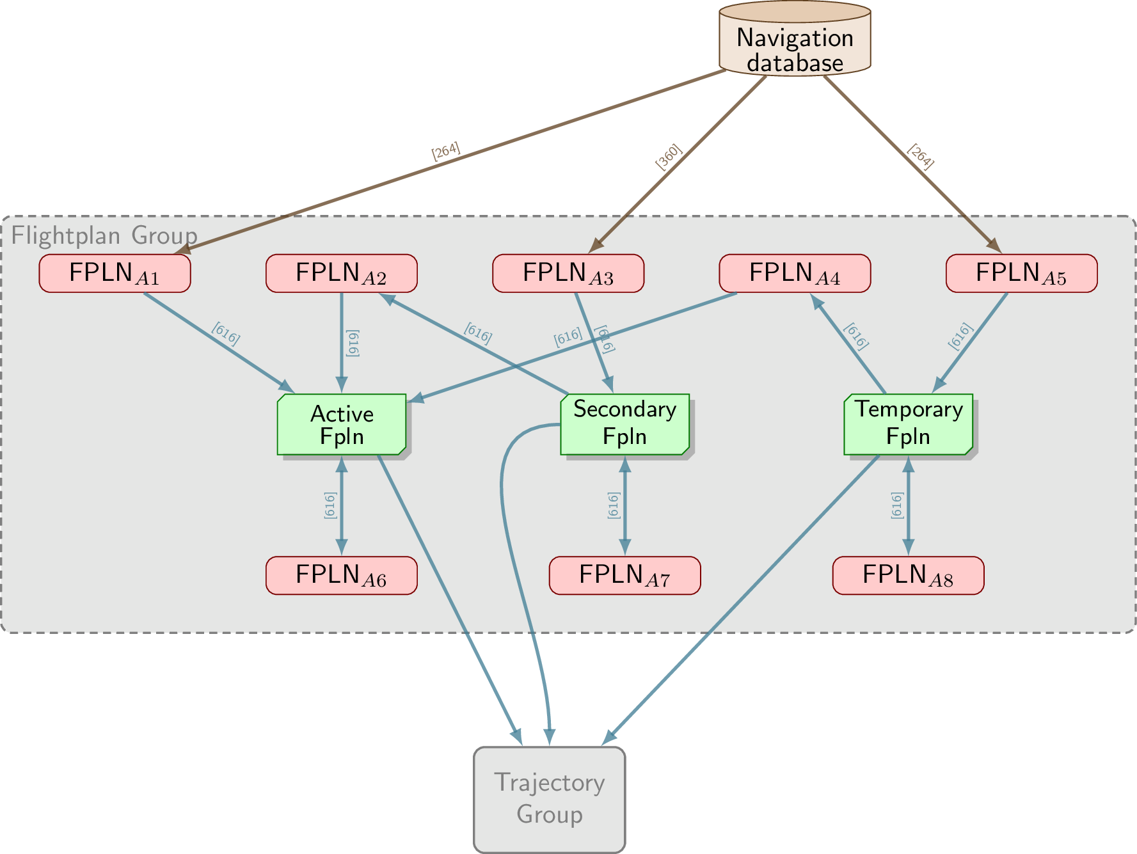

Figure 13. Flightplan task group

**Internal communications**: The internal communications of the Flightplan task group correspond to the aperiodic tasks defined above. Flightplan initialisations only write to the buffer corresponding to the flight plan. Flightplan copies and activations require both to read a flight plan buffer to write to another one. Finally, flight plan updates read and write to the same flight plan buffer.

**External communications:** The inputs used by the Flightplan task group come from the Navigation Database. The outputs correspond to the active, secondary and temporary flight plans passed by to the Trajectory task group.

### Trajectory task group

The trajectory task group aims at computing both lateral and vertical profiles for the three flight plans set by the flight plan task.

The lateral profile is composed of waypoints as well as leg information (path before, after and between the waypoints). Figure 14 provides a few leg examples among the 23 different kinds of existing legs: a) is a straightforward Track to a Fix (TF) leg; b) is a constant radius arc (RF) leg; and finally c) is the kind of hippodrome shaped legs used by plane around the destination airport while being in standby for landing agreement.

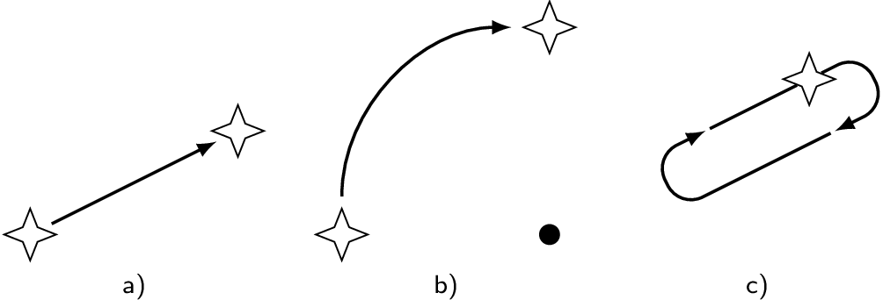

Figure 14. Three examples of leg types

#### Periodic tasks

The trajectory task group is composed of three periodic tasks, each independently managing a trajectory corresponding to one of the three flight plans:

* **TRAJR1**: Active trajectory. The active trajectory task performs the computation of the lateral and vertical profiles against the primary flight plan. This is a very critical computation-intensive task.
* **TRAJR2**: Secondary trajectory. The secondary trajectory task performs the computation of the lateral and vertical profiles against the secondary flight plan. This is a computation-intensive task.
* **TRAJR3**: Temporary trajectory. The temporary trajectory task performs the computation of the lateral and vertical profiles against the temporary flight plan. This is a computation-intensive task.

Requirement: Periodic trajectory real-time requirements

TRAJR1 should operate as a periodic task at a cycle frequency of 200ms, while TRAJR3 and TRAJR4 have a period of 300ms.

#### Aperiodic tasks

The purpose of **TRAJA1**, the aperiodic task of the trajectory task group is to initialise the feedback information corresponding to the real physical position of the aircraft. This information is set (and not used) even when the FMS has lost the place position. We use such a value to build meaningful traces of sensor information. In a real FMS, such information will be obtained from real sensors, and no feedback to the sensors would be necessary.

#### Task communications

Figure 15 illustrates both the internal buffers of the Trajectory task group, as well as internal and external communications.

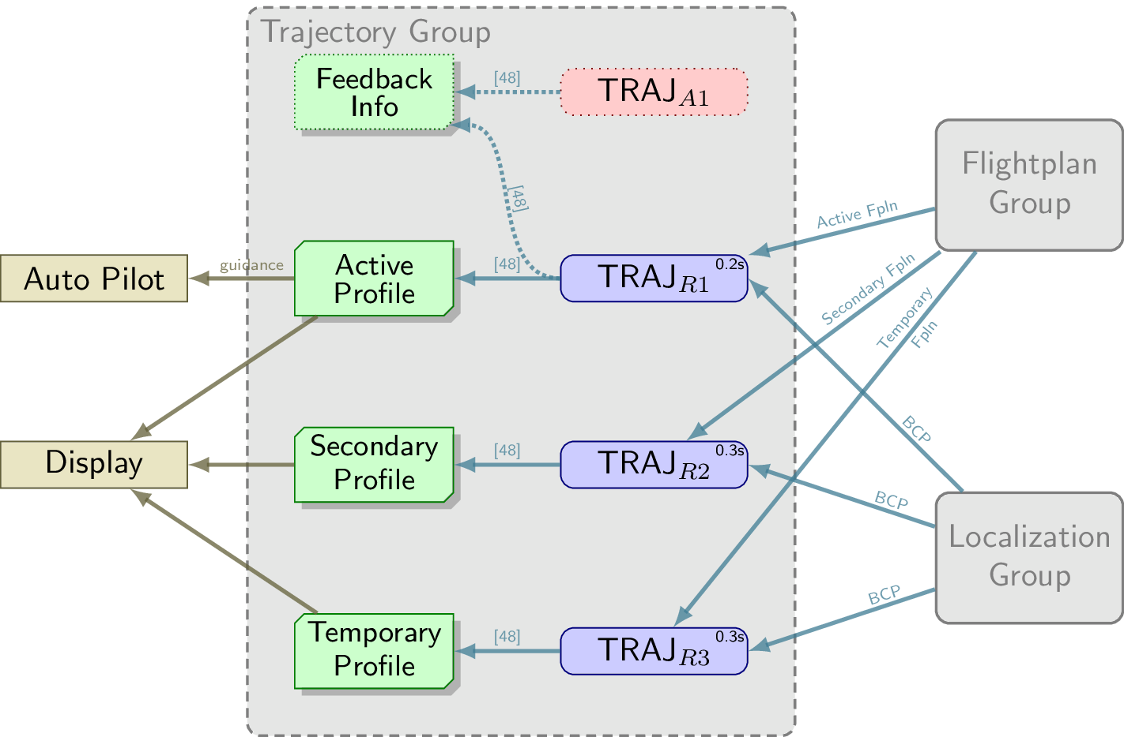

Figure 15. Trajectory task group

**Internal communications**: Tasks TRAJR1, TRAJR2 and TRAJR3 are respectively generating both lateral and vertical profiles corresponding to the active, secondary and temporary flight plans.

**External communications:** As Inputs to perform the trajectory computations the Trajectory task group requires both the BCP generated by the Localisation task group, and the flight plan data handled by the Flightplan task group. Flightplan updates will cancel the current trajectory computations. The outputs of the trajectory tasks are the lateral and vertical profiles. The active lateral and vertical profiles will be fed to the autopilot as guidance information.

### Nearest task group

The purpose of the Nearest Airports task group is to continually build during the flight the list of the nearest airports, in case the pilot would decide to have an impromptu landing for some reason.

The tasks from this task group do not participate directly to the flight management, the computed output has only to be sent to the display.

#### Periodic tasks

The Nearest Airports task group is only composed of a single periodic task:

* **NEARP1**: Airport list computation. This task is responsible for the computation of the nearest airport list using the current localisation of the aircraft. Building this list implies querying the navigation database, and computing loxodromic distance to all the airports to figure out the closest ones. As a consequence, this task is both memory intensive and computation intensive.

Requirement: Periodic nearest real-time requirements

The nearest airport list shall be computed by task NEARP1 in less than 3s, and displayed in less than 2s.

#### Task communications

Figure 16 illustrates both the internal buffers of the Nearest Airport task group, as well as internal and external communications.

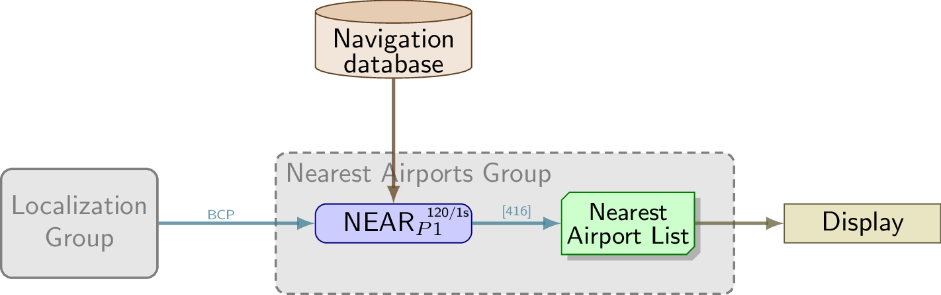

Figure 16. Nearest task group

**Internal communications**: Internal communications only consist of the task NEARP1 generating the list of the nearest airports.

**External communications**: The inputs of the Nearest Airports task group consist both of the navigation databases, and the best computed position computed by the Localisation task group. The output of this task, the nearest airports list is directly sent to the display.

### Global picture

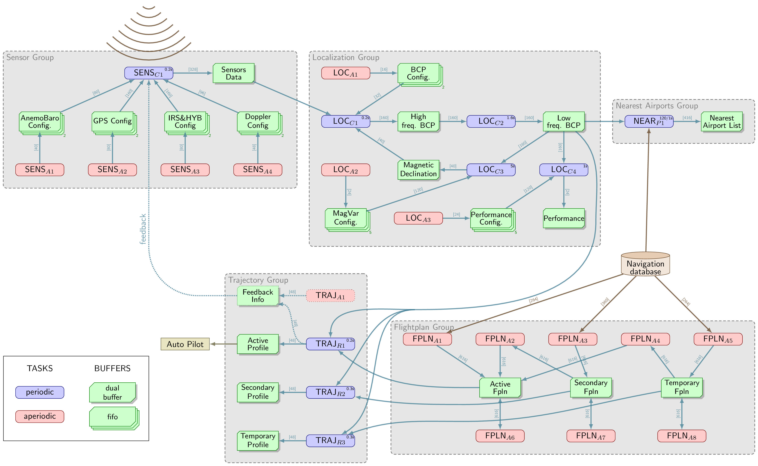

## Automotive: a convoy function (AD)

The following list is a summarised version of the user requirements derived for the automotive use case. The summary corresponds to the current version of the project requirements document ([Project requirements document release 1.0](https://unipiit.sharepoint.com/:x:/r/sites/TEACHING/Shared%20Documents/Requirements_project/Teaching_requirements_Release1.0_20201222.xlsx?d=w4dd4dacd656b46eab1087f5ed643d678&csf=1&web=1&e=e3AJew)), as described in the introduction of Section 4 on page 28.

Requirement group: Location

The CPS must be able to determine its location in relation to the ODD i.e. is it inside or outside of a location-specific ODD.

Requirement group: Object detection/perception (external environment)

To enable AD behaviour, all relevant entities (e.g. road users, infrastructure, obstacles etc.) must be perceived and optionally pre-processed. That is especially the case when considering safety-relevant entities.

An implemented environment model needs to predict the future state of relevant objects to form the basis for predicting future motion.

Requirement group: Object detection/perception (internal environment)

Driver presence must be detectable.

Driver facial landmarks must be identifiable.

Sensor data on driver physiological status must be available and where needed, it must be classified (e.g. gaze classification).

Requirement group: Driving safety

A collision-free and lawful driving policy must be ensured (e.g. safe distance to objects, comply with traffic rules etc.)

The system must initiate timely interventions in the safety-critical situations subject to the driver state.

Requirement group: Driving plan

A driving plan must be created and executed.

Requirement group: Communication

Communication channels to other road users must be established and utilised (3G/4G).

Internal communication must ensure that AIaaS modules can receive sensor data about the state of the vehicle.

Requirement group: System performance

Signs of adverse behaviour must be detected and eliminated so that the nominal performance of the system is maintained.

When needed, the CPS must degrade operation within a well-defined period. Detection of possible unavailability of the fail-degraded capability is also needed. Should degradation failures occur, necessary reactions are needed.

Mode transitions must be performed correctly and controlled by the vehicle operator if necessary.

A timely set of functional adaptation is needed within reduced system constraints.

It must be possible to integrate external sources through the ability to retrain (e.g. classification).

The sensor calibration changes should be allowed without the need to retrain (e.g. if the sensor location changes).

HMI should provide visual, auditive and haptic means of interaction by delivering suggested actions from AIaaS to the human.

The system should be able to classify cognitive load aspects (attention, distraction, emotion etc)

Requirement group: Dependability

KPI/QoS metrics are needed for an estimate of dependability/trust for an AI system.

The HW/SW platform constraints for AI-usage must be defined.

Relevant standards must be identified and adhered to.

Risk analysis must be performed (according to standards) (development and operational)

SW update procedure for a dependable system update is needed.

There is a need for adequate runtime adaptation methods.

AI decisions must be in line with identified confidence metrics.

There is a need for timely detection and notification of malicious activities.

Requirement group: GDPR compliance

Data management must be GDPR compliant.

## A combined picture – overall requirements

The combined set of user requirements is amalgamated and structured in a single document ([Project requirements document release 1.0](https://unipiit.sharepoint.com/:x:/r/sites/TEACHING/Shared%20Documents/Requirements_project/Teaching_requirements_Release1.0_20201222.xlsx?d=w4dd4dacd656b46eab1087f5ed643d678&csf=1&web=1&e=e3AJew)). This release continues to serve as a basis for the living set of requirements that are to adopt further changes subject to the findings of the TEACHING project. The requirements aim to provide application guardrails to the direction of the project. They also set the validation and verification scene for the computing, adaptation and dependability functionalities. The perspective offered by the industrial demonstrations is to support the evaluation of offered assets for industrialisation.

Beyond the structured assembly of the user requirements, these are also mapped to the hardware platform (T5.2), which is in development. The consensus is reached between the optimal user requirements and definition of components and characteristics that need to be incorporated into the HW platform for use by the TEACHING project. The platform is detailed in section 5. The starting point for the balancing act between the functionality and the hardware assets are the functional concepts of the UCs (depicted in Figure 17 and Figure 18). Both applications rely on data from a varying set of sensors. The data from the avionics UC is focusing solely on the vehicle (aircraft) and its environment, while the automotive UC also includes human at the sensing part of the loop. The data is interpreted using a set of algorithms that define the system stress levels. These data are used in training and inference. The avionics UC at that point includes the human (the pilot) into the control loop as the primary decision maker. On the other hand, the automotive UC relies on algorithms to perform decision making. Both UCs must obey policies and regulatory directives. Once the decisions are made and performed, the control loop is closed. The difference between the two UCs is the placement of the human within that loop. While the avionics UC uses the human as the primary decision maker, the automotive UC relies on observation of the human reactions as a sufficient informer for the decision making to be done by the machines themselves. Additionally, the automotive UC relies on the human driver being adequately prepared (alert) to take over the vehicle controls, when needed.

Figure 17. Avionics CPSoS Application

Figure 18. Automotive CPSoS Application

# TEACHING hardware platform

The TEACHING development hardware platform is briefly described in this section. It is confronted with the requirements to understand its compatibility with the project needs and to identify the possible tailor-made solution for both UCs. The aim is to integrate TEACHING algorithm solutions into a single HW demonstration platform for both UCs. At the same time, considering that TEACHING is facilitating modular CPSoS, the platform, as a core part of the solution, is also to enable the integration of other, technology agnostic, system components.

## Platform description

I&M’s experience is built upon own design of the Sensor Data Fusion (SDF) platform. That is a high performing electronic embedded system that can be easily integrated into a vehicle. Its core targets are sensor fusion algorithms and AV functions while relying on a diverse set of interfaces that make it generic enough to be used in other applications.

At the core of the system, there are two different processors. One of those incorporates many high-performance cores for computing-intensive tasks. The other processor is designed for more safety features and acts as the system supervisor and monitor. In practice, the high-performance processor is hosted on a System-on-Module compliant with the SMARC standard as shown in Figure 19.

1. 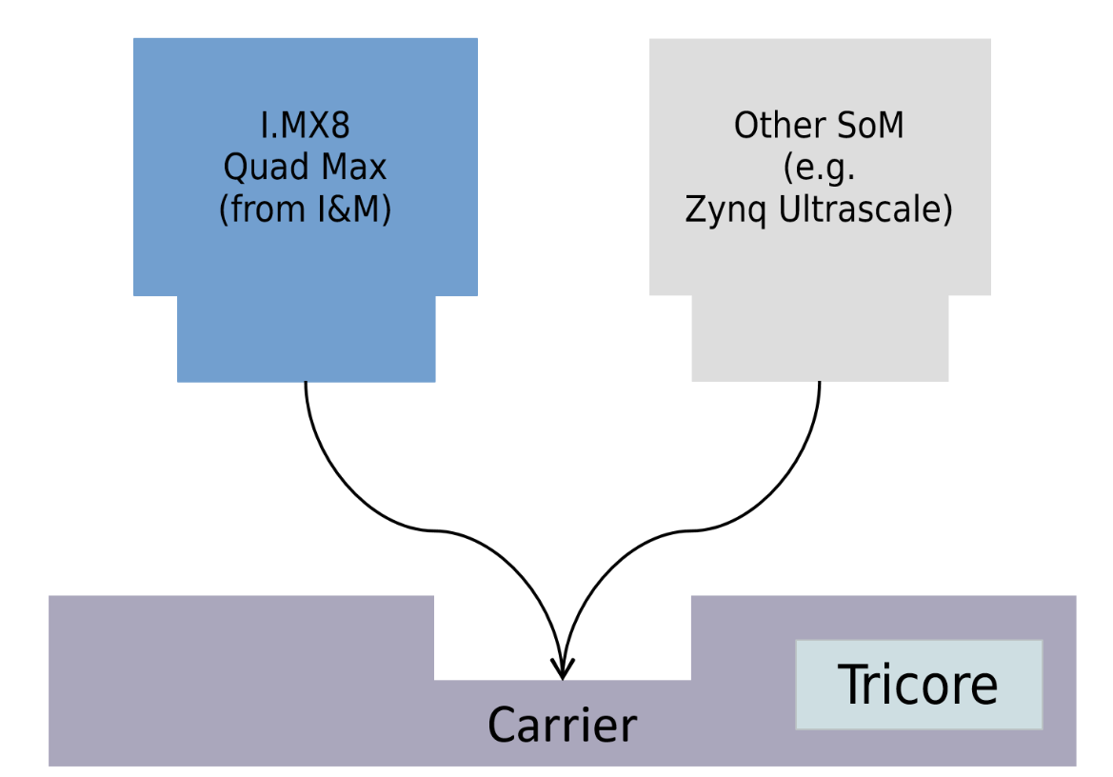

Figure 19. SDF partitioning into carrier and SoM

The SoM is based on the i.MX8 Quad Max from NXP. The SMARC standard ensures that it can be swapped with a different SoM. That replacement SoM could be based on a different architecture, e.g. it could be FPGA-based.

Regarding the i.MX8 Quad Max, it is a System on Chip with 4x Cortex-A53, 2x Cortex-A72, and 2x Cortex M4. The high number of cores, together with virtualisation support, make it suitable for Asymmetric Multi-Processing mode, where multiple Operating Systems are on different cores at the same time. Moreover, the presence of GPU makes this processor a viable choice for tasks in which the parallel computing architecture can be exploited. From the SW perspective, a suitable customised free version of Linux is already available, along with a couple of hypervisors.

The safety processor is Infineon’s Aurix TC387. This microcontroller targets the safest application of the automotive domain. It is designed with functional safety and security in mind, relying on lockstep cores to reach the ASIL D safety level [2]. Withing the SDF platform setting, the safety processor plays the role of state monitoring of other processes. Its may potentially shut down processes in case of their failure.

1. 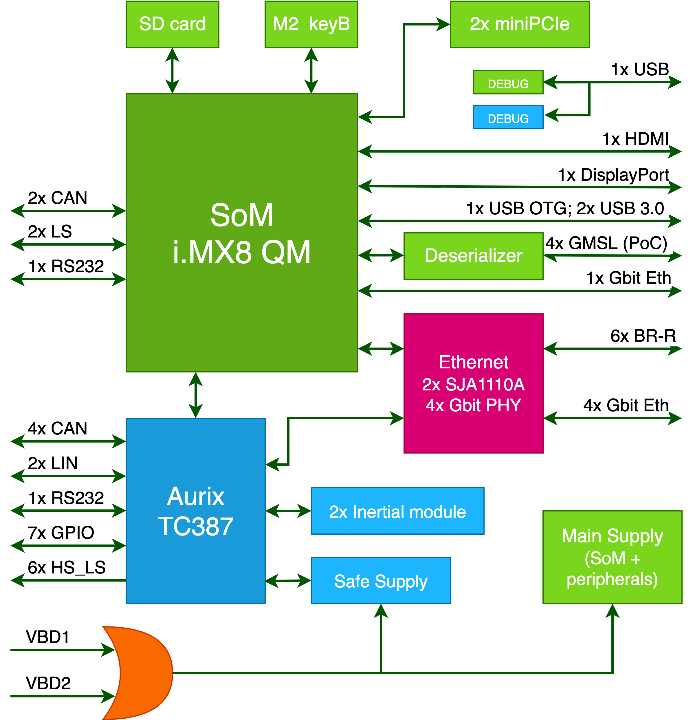Figure 20 depicts the architecture of the SDF platform. Two battery inputs are present for redundancy, and a safe power supply acts as a watchdog for the Aurix. MiniPCIe and M.2 slots are connected to the SoM and allow the addition of extra features, such as LTE connection. The two processors are interconnected through two on-board Ethernet switches that also extend the number of ports to 5 1000Base-TX and 6 100Base-T1. The switches are SJA1110 from NXP that implements several TSN (Time Sensitive Network) functionalities and Quality of Service (QoS) features. This implies a possibility for dependable data sharing on the network.

Figure 20. SDF internal architecture

An alternative to the i.MX8 SoM is a module from SECO that builds the Xilinx Zynq Ultrascale+ MPSOC (Multi-Processor System on Chip). It is a device that combines 64-bit Cortex-A cores and programmable logic. This allows energy-efficient and high-bandwidth computation. Xilinx supports the development by offering access to a wide range of tools under the name of Vitis. Those tools allow software developers to exploit the programmable hardware without hardware design knowledge. An additional tool, Vitis AI, deploys an accelerator on the programmable HW. The accelerator is used to optimise the most common NN frameworks. All these features make this device a suitable solution for applications in which the NN inference must be performed in realtime.

### Hardware Platform – Core Requirements

Considering the [Project requirements document release 1.0](https://unipiit.sharepoint.com/:x:/r/sites/TEACHING/Shared%20Documents/Requirements_project/Teaching_requirements_Release1.0_20201222.xlsx?d=w4dd4dacd656b46eab1087f5ed643d678&csf=1&web=1&e=e3AJew), the specific project requirements with a larger impact on the HW platform are enlisted in this section.

Requirement: Hardware observability - GP Core

Performance Monitor Counters shall be available for the general-purpose core and memory hierarchy (Performance Monitoring Unit available on CCI-400 Cache Coherent Interconnect and also on Cortex-A cores.)

Requirement: Hardware observability: AI Accelerator

Performance Monitor Counters should be available for the AI accelerator internals (If GPU is used, performance counter should be available. PMU available on Cortex-A.)

Requirement: Hardware observability: GP Core to/from AI Accelerator communications

Traffic between the general-purpose core and AI accelerator shall be monitorable, at least in terms of number/size of accesses (Satisfiable, implementation details needed in further steps)

Requirement: Target hardware memory

The target hardware shall embed a sufficiently large amount of memory (~32MB) of memory for the navigation database, code text segment and FMS data. To minimise main memory accesses during task execution, and therefore minimise timing interference the hardware platform also requires to embed some local memories (private cache hierarchy or private scratchpad memories). (32GB eMMC on i.MX8 SoM, 4GB eMMC on Zynq+ SoM)

Requirement: Trace collection

Hardware should provide a way to send traces to an external host running the learning algorithm that will pilot the IA, like Ethernet connection. This connection has to be supported by the RTOS. (Ethernet MAC presents on both i.MX8 and Aurix (both 10/100/1000 MBit/s))

Requirement: Monitor the GPP from the IA accelerator

Monitoring information of the software running on the GPP HW has to be sent/made accessible from the IA accelerator without significantly impacting timing interference. (IPC possible inside the SoC. To be defined which technique)

Requirement: Communicate and interact with other road users

Automated driving vehicles are required to communicate and interact with other road users, depending on the ODD and the use cases. (Cellular connection possible)

Requirement: Determine if specified nominal performance is not achieved

Any CPS element can result in adverse behaviour either on its own or in combination with others. Hence, mechanisms are required to detect adverse nominal system performance. (The Aurix can monitor the health status of the SoM and detect drops in performance.)

Requirement: HMI

HMI should provide viasual, auditive and haptic means of interaction. (i.MX8’s HDMI connection carries both audio and video. The Zynq+ has DP, with the same functionality.)

Requirement: Detect changes in car state or context

Use sensors and cameras either integrated to the car (accelerometers, gyroscopes, luminosity sensors, LIDAR, camera, IR beam and sonar) or attached by the driver to detect car's state and context (e.g. road and weather conditions, obstacles) to feed them in the human-centric personalised autonomous driving system. (There are two six-axis inertial modules on the carrier. Diverse interfaces make it possible to interface to several sensors.)

Requirement: Access to vehicle sensors data

Vehicle sensors (humans and vehicle) need to be accessible using a standard protocol

Requirement: Cellular 3G/4G connection

The vehicle shall be able to communicate with other road users and cloud via 3G/4G network. (Cellular connection possible through miniPCIe module on the carrier - accessible by SoM)

Requirement: In-Vehicle network interfaces

The platform shall have CAN, LIN and it may have BroadR-Reach for interfacing with vehicle sensors and other ECU (The Aurix and i.MX8 (and Zynq+) both have CAN and both can access to BroadR-Reach ports. Only Aurix has LIN interface.)

## Safety assessment/analysis

As the interface from the training and inference towards the control part of Figure 18, the focus shifts from human perception of driving and associated comfort, towards the monitoring and control of the application i.e. either vehicle control or plane monitoring. Hence, there is a need to consider safety analysis/assessment, as the HW platform is directly involved in safety-critical applications. Although TEACHING does not directly develop ADAS/AD functions (automotive UC), these features are to be running on the platform.

The existing HW platform offers a few safety features, some of which are intrinsic to the used components. Firstly, the Aurix TC387 includes the following useful safety features:

* support in system design up to ASIL D
* built-in self-tests with the possibility to detect internal faults and possibly, after repeated fault detections, exclude itself from the system in order to prevent it from acquiring wrong data from the Aurix itself
* two lockstep cores performing in parallel the same instructions with a different logic and a coherency check of the final result, hence allowing random hardware error detection.

Secondly, the system architecture provides further protection: safe power supply provided by the TLF35584 ensures ASIL D safety grade in conjunction with the Aurix. The TLF includes a voltage regulator, a watchdog, and built-in self-tests. It is also developed to comply with ASIL D.

While the TLF controls the correct functioning of the Aurix, the Aurix itself checks the correct functioning of the SoM on the board. In particular, the Aurix monitors the SoM state, checking for possible faults and performance drops to avoid undesired side effects in both cases.

## Possible usage in the use cases

The SDF has features that make it a suitable solution for both avionic and automotive use cases.

In the avionic case, a tentative allocation of the SW module to HW resource is done. It shows some advantages of using i.MX8, as its two separate Cortex-A core clusters (4xA53 and 2xA72) allow running isolated SW pieces. It does not appear to fit on the FPGA, because it has a single cluster of Cortex-A53 cores.

On the other hand, considering the more dynamic nature of the automotive use case, it is likely to generate higher sensors volumes of data that must be processed and fed to a NN. In that case, the solution, which integrates an FPGA, demonstrates better characteristics since it delivers higher performances at lower energy consumptions thanks to the programmable HW.

Consequently, the tailored adaptation of the HW and UC requirements leads to a conclusion to utilise SDF as a base solution for both demonstrations, automotive and avionics. However, in the avionics use case, the SoM with i.MX8 Quad Max from I&M will be used, while in the automotive demonstration the SDF will be deployed with an SoM hosting an Ultrascale Zynq+ from Xilinx.

# Conclusion

Considering the crucial aspect of WP5, which is to enable a sustainable integration of the project assets with the two industrial UCs (AD and aviation functions), the main function of the work behind this deliverable is to assemble high-level application requirements and overall specifications for the proposed UCs. The two-fold function of those requirements and specifications is seen in informing other (technical) WPs of necessary direction for industrialisation of the project outcomes, as well as in preparatory work for testing of the project outcomes in real industrial scenarios. Looking from the perspective of UCs, both are expected to benefit from AI techniques in the form of a radical increase of CPSoS performance, functionality and customisation capabilities.

The specific objective of WP5 for the first year of the project is to design and define the architecture and requirements of the TEACHING avionics and automotive use cases. Besides the consolidation of the relevant requirements (T5.1), the offered conceptualisation is to consider tailoring of TEACHING technology bricks to maximise the exploitation potential of the offered solutions (T5.2).

Consequently, this document provides an overview of the results yielding from the work conducted in T5.1 with additional support from T5.2. The key points to consider are:

* The selection of the requirements for avionics use case including the functional description and the mapping of the desired functions to the target HW.
* Definition of the highway platooning UCs
* Consideration of the dependability aspects and their integration into the UC definitions
* Considerations of demonstrability of the project assets in realistic but controlled scenarios
* The conceptualisation of the HW architecture and its tailoring to comply with the needs of both UCs
* Holistic tailoring of the existing HW platform to desired functionality and its compliance to the relevant standards

Comparison of the achievements to the initial intentions lets itself to a conclusion that the initial objectives of WP5 are considered to be achieved. This WP will continue to be active in the following 2 years of the project.

# References

|  |  |
| --- | --- |
| [1] | SAE, “Taxonomy and definitions for terms related to driving automation systems for on-road motor vehicles,” SAE, 2018. |
| [2] | International Organization for Standardization (ISO), *ISO 26262-3:2018 Road vehicles — Functional safety — Part 3: Concept phase,* 2018. |
| [3] | ISO - International Organization for Standardization, ISO/SAE CD 21434 - Road vehicles - cybersecurity engineering, ISO - International Organization for Standardization, 2018. |
| [4] | ISO - International Standardisation Organisation, “ISO 21448 - Road vehicles — Safety of the intended functionality,” ISO - International Standardisation Organisation, 2019. |
| [5] | G. Macher, C. Schmittner , O. Veledar and B. Brenner, “ISO/SAE DIS 21434 Automotive Cybersecurity Standard - In a Nutshell,” in *SAFECOMP 2020. Lecture Notes in Computer Science*, 2020. |
| [6] | ISO - International Standardization Organisation, ISO 26262 Road vehicles - Functional safety, ISO - International Standardization Organisation, 2018. |

1. † *The research leading to these results has received funding from the European Union’s Horizon 2020 research and innovation programme under grant agreement No 871385.*